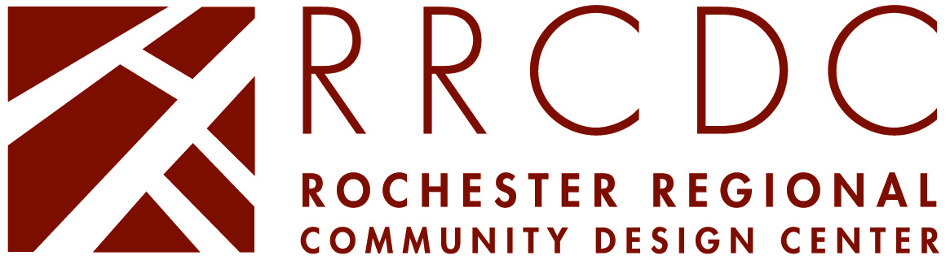

Request For Qualifications Submission Requirements
Development/Design Fund Program

FIRM PROFILE

Firm profiles, including background narratives, visuals, and supporting documents, are kept on file at the Rochester Regional Community Design Center (RRCDC). Following each grant commitment, copies of these materials are emailed to the community-based organization for review.

We are only accepting submissions in electronic format (.pdf). Please create one .pdf with this document and the requested information. Limit your file to 10mb. Contact Sebastian Baliva at design@rrcdc.org or (585) 271-0520 with any questions.

I. Background Narrative
Please provide the following information, in narrative or outline form (maximum 3 pages, not including requested attachments):

- Contact Person
- Address/Phone Number/Fax Number/E-mail
- Brief description of the firm, including number of employees and years in operation
- Firm’s approach to staffing small, non-profit projects. Please describe the level of involvement of owners, principals, and senior staff
- Typical hourly billing rates by position
- Brief discussion of firm’s experience, including a list of current and completed projects (firm of record must be credited)
- References: Include contact names and daytime phone numbers for at least three references, preferably for work with non-profit or community based organizations and/or first time users of consulting services.
- MBE/WBE Certification(s) (if applicable). Please attach copies of certificate(s).
- Professional Insurance Coverage. If none, indicate self-insured.

II. Visual Examples of the Firm’s Work (6 page max)
Include copies of drawings and/or photographs that effectively illustrate the firm’s work, recognizing that RRCDC funded projects are developed within an urban context.

III. Other Supporting Material (optional)
Provide any other supporting material, such as additional visuals or a US GSA Form 254 that you would like us to keep on file.

SPECIALIZATION & INTEREST

I. Areas of Specialization
Select a maximum of 4 from the following list of 12. Your selections help the RRCDC short-list appropriate firms for projects. If one of your particular areas of expertise does not appear on the list, or you are not sure which category to select, please contact our office.

Architecture
Residential – renovation and new construction
Residential – elderly
Commercial – renovation and new construction
Community/ Day Care/Education/Social Service Facilities
Industrial/Warehouse Facilities
Historic Restoration

Planning
Master Planning (including facility and campus planning)
Urban Design (including streetscapes, facades, and design standards)
Community Planning (including land use studies and development strategies)

Landscape Architecture
Residential Landscape Design
Commercial Landscape Design
Parks & Recreation

II. Additional Areas of Interest
The RRCDC also provides other forms of technical assistance to community-based organizations. The success of these programs is dependent not only on the efforts our staff, but also a variety of consultants who help us on a volunteer or paid basis. Please read the following information and check the appropriate box(s) to indicate the firm’s interest in these programs:

Design Consults
We are always seeking additional volunteers, including architects, interior designers, landscape architects and structural engineers, to help us with community design charrettes and design teams developing vision plans. Please let us know if there is interest in involvement with these activities:

Members of our firm are already involved.
Please contact our firm to discuss how we may become involved.
We are not interested at this time.

Architectural Services for Individual Building Owners
From time to time the RRCDC receives calls from individual building owners seeking architects for small residential or commercial projects. Often callers are low- to moderate income and have not worked with an architect before. Although the Design Center does not recommend firms, we forward a list of consultants that are interested in such work.

Please forward our firm profile.
We are not interested at this time.

Consulting Work for Community-Based Organizations
Each year the Design Center responds to a number of requests for technical assistance from CBOs throughout the City of Rochester and neighboring communities. The RRCDC will provide technical assistance on an informal basis. In some of these cases, we may need to turn to design or community development consultants for professional expertise. The consultant’s contribution will depend on the situation, and the firm may be asked to provide the work on a pro-bono or honorarium basis.

Please contact our firm to discuss how we might offer assistance.
We are not interested at this time.

